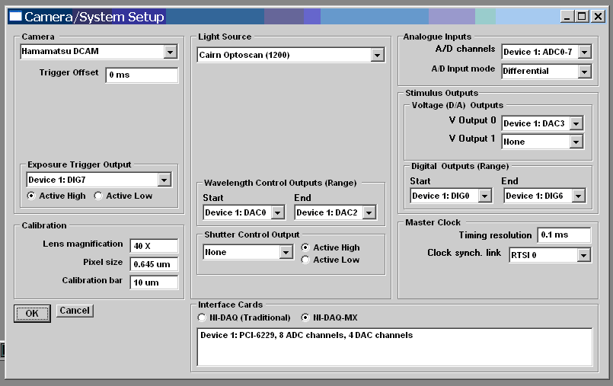

Note. Left/right panel means the BNC2110 panel connected to the left/right hand socket on the PCI-6229 board.

Optoscan outputs | DAC0 – DAC2 | DAC0 = DAC0 (left panel)  DAC1 = DAC1 (left panel)  DAC2 = DAC0 (right panel)
Voltage clamp Vcommand  V Output 0 | DAC3 | DAC3 = DAC1 (right panel)
Camera trigger | PO7 – User 1 | PO7 (left panel)
Digital stimulus 0 | DIG0 | PO0 (left panel)
Digital stimulus 1 | DIG1 | PO1 (left panel)
Digital stimulus 2 | DIG2 | PO2 (left panel)
Digital stimulus 3 | DIG3 | PO3 (left panel)
Digital stimulus 4 | DIG4 | PO4 (left panel)
Digital stimulus 5 | DIG5 | PO5 (left panel)
Digital stimulus 6 | DIG6 | PO6 (left panel)

